Name: __________________________
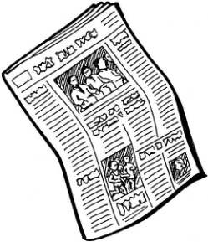
By Philip Konac
- Go to the website: www.newsinlevels.com.

- Choose any news on the level your teacher has assigned for you.

- Write the headline here: ____________________________________________________

- Use the fortune-teller. What do you think the news is about? ________________________________________________________________________________________________________________________________________________________________________________________________________________________________________________________________________________________________________________________________________________________________________________________________________________________________________________________________________

- Listen to the text in the video.

- Read the news text twice for yourself. If you’re working in pairs, read it aloud to your classmate.

- Use the detective. Write five words or sentences that you don’t understand. Ask a friend who’ll explain it in English. ________________________________________________________________________________________________________________________________________________________________________________________________________________________________________________________________________________________________________________________________________________________________________________________________________________________________________________________________________________________________________________________________________

- Use the reporter and write five questions about the text. Write a question on the line, a question between the lines and, finally, a question beyond the lines. Use whatever type of question you wish for the two remaining questions. (Let a friend answer them.) ____________________________________________________________________________________________________________________________________________________________________________________________________________________________________________________________________________________________________________________________________________________________________________________________________________________________________________________________________________________________________________________________________________________________________________________________________________________________________________________________________________________________________________________________________________________________________________________
- Use the cowboy. Sum up the text in about five sentences. (Before you do, create a mind map if you want.) _________________________________________________________________________________________________________________________________________________________________________________________________________________________________________________________________________________________________________________________________________________________________________________________________________________________________________________________________________________________________________________________________________________________________________________________________________________

- What pictures popped up in your head when you read the news? Write and paint a small picture beneath.

Explain the picture: ___________________________________________________________

